Title: **Latching Outputs** Handout: 5

Course: Introduction to Automation Unit: Introduction of PLC CLO: 4

**Objectives**

1. Student shall develop a knowledge of the Output Latch (OTL) output instruction.
2. Student shall develop a knowledge of the Output Unlatch (OTU) output instruction.

**Theory**

Output Latch (OTL)

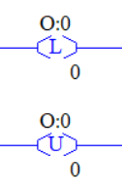This instruction functions much the same as the OTE with the exception that once an address bit is set through an OTL, it is "latched" on. The bit will remain "on" even if rung continuity is lost. The bit must be reset with an OTU instruction.

Output Unlatch (OTU)

Use this output instruction to unlatch a bit which was latched by an OTL instruction. The OTU address must be identical to the OTL address which originally set the bit. Output addresses are specified to the bit level.

**Graphics**

|  |  |
| --- | --- |
| OTL | OTU |
|  |  |

**Devices**

|  |  |  |
| --- | --- | --- |
| Inputs | | |
| *Device* | *Description* | *Symbol* |
| NC Pushbutton (PB1) | Reset Counter | CNT_RST |
| NO Pushbutton (PB2) | Count Up | CNT_UP |
| NO Pushbutton (PB3) | Count Down | CNT_DW |
| Outputs | | |
| *Device* | *Description* | *Symbol* |
| Green Pilot Light | Count Up Enabled | CTU_EN |

**Instructions**

Program the follow logic.

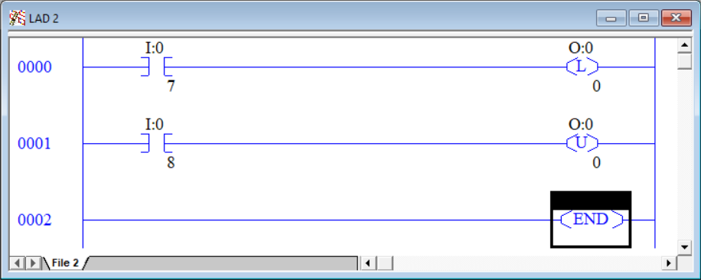

1. Press and release PB2. Notice that the green light illuminates and stayes on even though PB2 is no longer being pressed.
2. Press and release PB3. Notice that the green light goes out and stays off even after PB3 was released.
3. Latching and unlatching instructions can be used in leu of the sealing circuits we have used thus far.

Program the logic shown below.

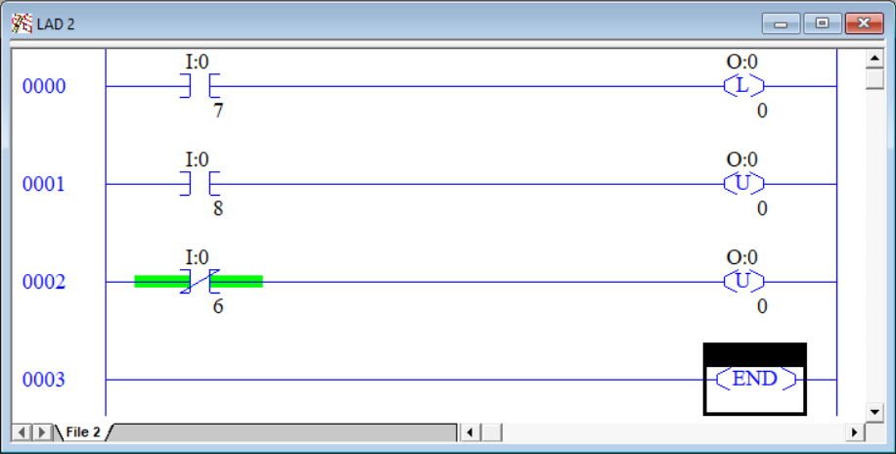

1. Press and release PB2 to latch in the green light.
2. Press and release PB3 to unlatch the green light.
3. Press and release PB2 to latch in the green light.
4. Press and release PB1 to unlatch the green light. There is no restriction on how many unlatch instructions that can be assigned to an address.

Program the logic shown below.

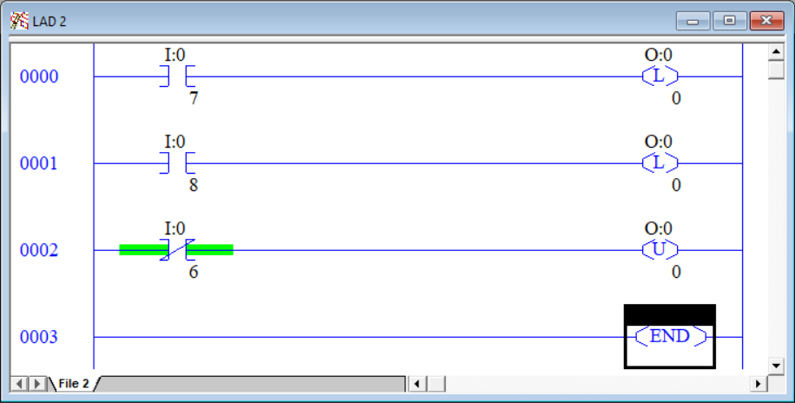

1. Press and release PB2 to latch in the green light.
2. Press and release PB1 to unlatch the green light.
3. Press and release PB3 to latch in the green light. There is no restriction on how many latch instructions that can be assigned to an address.
4. Try building your own motor start/stop with ESTOP circuit using only OTL and OTU instructions for the output to the motor.